**Vidya Bhawan Public School**

**Project report on**

**Student Management System**

**Session: 2022-23**

**Student Details:**

**Name :**Karan Suthar

**Class :**12th

**Roll no :**

**Subject :**Computer Science(083)

**Sub. Teacher :**Mrs. Neha Kataria

# **CERTIFICATE**

This is to certify that **JAYDEEPSHRIMALI**astudentofClassXIISciencehassatisfactorilycompletedtheprojectEntitled “**Grocery Store Management**”, under my **Mrs.NEHA KATARIA Ma’am** guidance and supervision duringthesession2022-2023.

## Iappreciatehiskeeninterestandsincereeffortsincovering all details of the project in a very systematicmanner. Iamvery pleased withhisproject.

**SUBJECTTEACHE PRINCIPAL EXAMINER**

# **ACKNOWLEDGEMENT**

## I would like to express my special thank of gratitude to my Computer Science teacher **Mrs. NEHA KATARIA Ma’am** for her able guidance and support and letting me work on this wonderful project.

I would also like to extend my deep gratitude towards our honourable Principal **Mrs.NEERJA JAIN Ma’am** for providing us all the required facilities and services.

**Karan Suthar**

XII(Science)

# **INDEX**

|  |  |  |
| --- | --- | --- |
| **S NO.** | **TOPICS** | **PAGE NO.** |
| 1. | INTRODUCTION | 1 |
| 2. | STRUCTURE OF PROJECT | 2 |
| 3. | ADMIN PANEL | 3 - 4 |
| 4. | USER PANEL | 5 |
| 5. | SOURCE CODE | 6 - 14 |
| 6. | OUTPUTS | 15 - 19 |
| 7. | TABLE STRUCTURE | 20 -21 |
| 8. | BIBLIOGRAPHY | 22 |

**INTRODUCTION**

The **Student Data Management System** is designed to efficiently handle student records within an educational institution. It streamlines administrative tasks related to student data, including **adding new student profiles**, **updating existing information**, and **removing outdated records**. Through this system, administrators can maintain accurate and up-to-date student details, ensuring smooth operations and effective communication.

**Working:**

* The basics functionality of this is based on mysql which facilates a database and tkinter which provides an gui for better interaction with user .
* This programme provides the an interface for both student and admin where student can see his/her data whereas an admin can manipulate the data of students which includes adding new student profiles, updating existing information, and removing outdated records.

**STRUCTURE OF PROJECT**

1. **Login Window:**
   * Users (both students and administrators) access the system through the login window.
   * The login window prompts users to enter their credentials (username and password).
   * Upon successful authentication, the system grants access to the appropriate interface.
2. **Student Interface:**
   * After logging in, students are directed to their personalized interface.
   * Here, students can view their personal information (name, roll number, contact details, etc.).
3. **Admin Interface:**
   * Administrators (such as teachers, school staff, or system administrators) access the admin panel.
   * Key functionalities in the admin interface include:
     + Adding New Student Profiles:
       - Admins can register new students by inputting their details.
     + Updating Existing Information:
       - Admins can modify student records.
     + Removing Outdated Records:
       - If a student leaves the institution or graduates, admins can archive or delete their records.

**FILE STRUCTURE OF PROJECT**

**SOURCE CODE:**

**Backend.py**

import mysql.connectoras sql  
from CTkMessageboximport CTkMessagebox  
  
  
def insert_student_record(roll, name, class_number, date, gender, phone_number, guardian_name, address):  
*# if gender == 0:  
 # gender = "Male"  
 # else:  
 # gender = "Female"*query = "INSERT INTO STUDENT_RECORDS (roll_number, name, class, Date_Of_Birth, Gender, Phone_Number, Guardians_Name, Address)" \  
" VALUES ({}, '{}', {}, '{}', '{}', '{}', '{}', '{}' )".format(str(roll), name,  
str(class_number), date, gender,  
str(phone_number), guardian_name,  
 address)  
try:  
cursor.execute(query)  
mydb.commit()  
CTkMessagebox(message="Data is Inserted successfully.",  
icon="check", option_1="Ok")  
print("data entry success")  
except Exception as e:  
CTkMessagebox(title="Error", message=("Something went wrong!!!\n {}".format(e)), icon="cancel")  
  
  
  
def update_student_record(roll, field, updated_value):  
query = "update student_records set {} = \"{}\" where Roll_Number={}".format(field, updated_value, roll)  
*#update student_records set name = where Roll_Number={}*try:  
cursor.execute(query)  
mydb.commit()  
CTkMessagebox(message="Data is Updated successfully.",  
icon="check", option_1="Ok")  
print("data update success")  
except Exception as e:  
print(e)  
CTkMessagebox(title="Error", message=("Something went wrong!!!\n {}".format(e)), icon="cancel")  
  
def delete_student_record(roll):  
query = "delete from student_records where roll_number = {}".format(roll)  
try:  
cursor.execute(query)  
mydb.commit()  
CTkMessagebox(message="Data is Deleted successfully.",  
icon="check", option_1="Ok")  
print("data delete success")  
except Exception as e:  
CTkMessagebox(title="Error", message="Something went wrong!!!", icon="cancel")  
  
  
def get_all_data():  
mydb.commit()  
cursor.execute('SELECT * FROM STUDENT_RECORDS')  
data = cursor.fetchall()  
return data  
  
def get_student_data(roll):  
mydb.commit()  
cursor.execute('SELECT * FROM STUDENT_RECORDS')  
data = cursor.fetchall()  
student_data= ()  
for iin data:  
if i[0] == int(roll):  
student_data= i  
break  
  
 return student_data  
  
  
  
mydb = sql.connect(host="localhost", user="root", passwd="root") *# Establishing SQL connection*cursor = mydb.cursor() *# Creating Cursor object*cursor.execute("CREATE DATABASE IF NOT EXISTS STUDENT_MANAGEMENT_SYSTEM")  
cursor.execute("USE STUDENT_MANAGEMENT_SYSTEM")  
cursor.execute('''  
CREATE TABLE IF NOT EXISTS STUDENT_RECORDS (  
Roll_Number INT PRIMARY KEY,  
 Name VARCHAR(50),  
 Class INT,  
Date_Of_Birth DATE,  
 Gender ENUM('Male', 'Female'),  
Phone_Number BIGINT,  
Guardians_Name VARCHAR(50),  
 Address VARCHAR(255)  
);  
''')

**Admin_panel.py**

import customtkinteras c  
from CTkTableimport CTkTable  
from Backend.backendimport *  
from Center_windowimport center_window  
  
  
def create_admin_window():  
root = c.CTk()  
root.title("Student Form")  
root.resizable(False, False)  
root.columnconfigure(1, weight=3, uniform="a")  
root.columnconfigure(2, weight=7, uniform="a")  
  
def panel_selector(value, frame):  
frame.destroy()  
  
frame = c.CTkFrame(root)  
frame.grid(row=1, column=0, sticky="news", padx=10, pady=10)  
  
if value == "Delete": *# create delete window  
 # Roll Number Label and Entry*roll_number_label= c.CTkLabel(frame, text="Roll Number to be deleted ")  
roll_number_label.grid(row=0, column=0, sticky="we", columnspan=3, padx=10, pady=(10, 0))  
  
roll_number_entry= c.CTkEntry(frame)  
roll_number_entry.grid(row=1, column=0, sticky="we", columnspan=3, padx=10, pady=(0, 10))  
  
*# Instruction Label*instruct = c.CTkLabel(frame,  
text="All the data of the student with the selected roll number will be deleted")  
instruct.grid(row=0, column=3, columnspan=3, sticky="news", padx=10, pady=(10, 0))  
  
*# Delete Button*delete_button_button= c.CTkButton(frame, text="Delete",  
command=lambda: delete_student_record(roll_number_entry.get()))  
delete_button_button.grid(row=3, column=0, columnspan=3, sticky="we", padx=10, pady=10)  
  
  
elifvalue == "Update": *# create update window  
 # Roll Number Label and Entry*roll_number_label= c.CTkLabel(frame, text="Roll Number")  
roll_number_label.grid(row=0, column=0, sticky="w", padx=10, pady=(10, 0))  
  
roll_number_entry= c.CTkEntry(frame)  
roll_number_entry.grid(row=1, column=0, sticky="we", padx=10, pady=(0, 10))  
  
*# Field to Update Label and Combobox*field_label= c.CTkLabel(frame, text="Field to Update")  
field_label.grid(row=0, column=1, sticky="w", padx=10, pady=(10, 0))  
  
fields = ["Name", "Class", "Date_Of_Birth", "Gender", "Phone_Number", "Guardians_Name", "Address"]  
field_combobox= c.CTkOptionMenu(frame, values=fields)  
field_combobox.grid(row=1, column=1, sticky="we", padx=10, pady=(0, 10))  
  
*# New Value Label and Entry*new_value_label= c.CTkLabel(frame, text="New Value")  
new_value_label.grid(row=0, column=2, sticky="w", padx=10, pady=(10, 0))  
  
new_value_entry= c.CTkEntry(frame)  
new_value_entry.grid(row=1, column=2, sticky="we", padx=10, pady=(0, 10))  
  
*# Update Button*update_data_button= c.CTkButton(frame, text="Update",  
command=lambda: update_student_record(roll_number_entry.get(),  
field_combobox.get(),  
new_value_entry.get())  
 )  
update_data_button.grid(row=2, column=0, columnspan=2, sticky="we", padx=10, pady=10)  
  
else: *# create insert window  
 # Create labels and entry fields*roll_number_label= c.CTkLabel(frame, text="Roll Number")  
roll_number_label.grid(row=0, column=0, sticky="w", padx=10, pady=(10, 0))  
roll_number_entry= c.CTkEntry(frame)  
roll_number_entry.grid(row=1, column=0, sticky="we", padx=10, pady=(0, 10))  
  
name_label= c.CTkLabel(frame, text="Name")  
name_label.grid(row=0, column=1, sticky="w", padx=10, pady=(10, 0))  
name_entry= c.CTkEntry(frame)  
name_entry.grid(row=1, column=1, sticky="we", padx=10, pady=(0, 10))  
  
class_label= c.CTkLabel(frame, text="Class")  
class_label.grid(row=0, column=2, sticky="w", padx=10, pady=(10, 0))  
class_entry= c.CTkEntry(frame)  
class_entry.grid(row=1, column=2, sticky="we", padx=10, pady=(0, 10))  
  
dob_label= c.CTkLabel(frame, text="Date Of Birth")  
dob_label.grid(row=0, column=3, sticky="w", padx=10, pady=(10, 0))  
dob_entry= c.CTkEntry(frame)  
dob_entry.grid(row=1, column=3, sticky="we", padx=10, pady=(0, 10))  
  
gender_label= c.CTkLabel(frame, text="Gender")  
gender_label.grid(row=0, column=4, sticky="w", padx=10, pady=(10, 0))  
gender_entry= c.CTkEntry(frame)  
gender_entry.grid(row=1, column=4, sticky="we", padx=10, pady=(0, 10))  
  
phone_label= c.CTkLabel(frame, text="Phone Number")  
phone_label.grid(row=0, column=5, sticky="w", padx=10, pady=(10, 0))  
phone_entry= c.CTkEntry(frame)  
phone_entry.grid(row=1, column=5, sticky="we", padx=10, pady=(0, 10))  
  
guardian_label= c.CTkLabel(frame, text="Guardians Name")  
guardian_label.grid(row=0, column=6, sticky="w", padx=10, pady=(10, 0))  
guardian_entry= c.CTkEntry(frame)  
guardian_entry.grid(row=1, column=6, sticky="we", padx=10, pady=(0, 10))  
  
address_label= c.CTkLabel(frame, text="Address")  
address_label.grid(row=0, column=7, sticky="w", padx=10, pady=(10, 0))  
address_entry= c.CTkEntry(frame)  
address_entry.grid(row=1, column=7, sticky="we", padx=10, pady=(0, 10))  
  
insert_data_button= c.CTkButton(frame, text="insert", command=lambda: insert_student_record(  
roll_number_entry.get(), name_entry.get(), class_entry.get(), dob_entry.get(), gender_entry.get(),  
phone_entry.get(), guardian_entry.get(), address_entry.get()))  
  
insert_data_button.grid(row=2, column=0, columnspan=2, sticky="we", padx=10, pady=10)  
  
frame_panel= c.CTkFrame(root)  
frame_panel.grid(row=1, column=0, sticky="news", padx=10, pady=(0, 10))  
  
seg_selector= c.CTkSegmentedButton(root, values=["Insert", "Update", "Delete"],  
command=lambda value, frame=frame_panel: panel_selector(value, frame))  
seg_selector.grid(row=0, column=0, sticky="news", padx=10, pady=(10, 0))  
seg_selector.set("Insert")  
  
panel_selector("Insert", frame_panel)  
  
frame_headings= c.CTkFrame(root)  
frame_headings.grid(row=2, column=0, sticky="news", padx=10, pady=(10, 0))  
  
labels = \  
 [c.CTkLabel(frame_headings, text="Roll Number", width=150),  
c.CTkLabel(frame_headings, text="Name", width=150),  
c.CTkLabel(frame_headings, text="Class", width=130),  
c.CTkLabel(frame_headings, text="Date Of Birth", width=150),  
c.CTkLabel(frame_headings, text="Gender", width=140),  
c.CTkLabel(frame_headings, text="Phone Number", width=130),  
c.CTkLabel(frame_headings, text="Guardians Name", width=200),  
c.CTkLabel(frame_headings, text="Address", width=150)]  
*# Applying characteristics to each label*for label in labels:  
label.grid(row=0, column=labels.index(label), sticky="we")  
  
*# to delete the data in realtime*def update_table(previous_data, table):  
new_data= get_all_data()  
  
if new_data!= previous_data: *# i.e. there is a change in data*table.destroy()  
previous_data= new_data  
if len(new_data) >12:  
table = CTkTable(scrollable_frame, row=len(new_data), column=8, values=previous_data)  
table.grid(sticky="nsew", columnspan=8)  
else:  
table = CTkTable(scrollable_frame, row=12, column=8, values=previous_data)  
table.grid(sticky="nsew", columnspan=8) *# to not change the number of rows*root.after(5000, update_table, previous_data, table) *# pass the reference, not the result of the function call*scrollable_frame= c.CTkScrollableFrame(root, width=1200, height=400)  
scrollable_frame.grid(row=3, column=0, sticky="news", padx=10, pady=(5, 10))  
  
initial_data= get_all_data()  
  
table_widget= CTkTable(scrollable_frame, row=20, column=8, values=initial_data)  
table_widget.grid(sticky="nsew", columnspan=8)  
  
update_table(initial_data, table_widget)  
  
center_window(root)  
root.mainloop()

**Center_window.py**

def center_window(window):  
*# Get the screen resolution*screen_width= window.winfo_screenwidth()  
screen_height= window.winfo_screenheight()  
  
*# Get the window size*window.update_idletasks() *# Ensure that the window size is updated*req_width= window.winfo_reqwidth()  
req_height= window.winfo_reqheight()  
  
*# Calculate the X and Y coordinates to center the window*x = (screen_width- req_width) // 2  
y = (screen_height- req_height) // 2  
  
*# Set the position of the window*window.geometry(f"+{x}+{y}")

**Login.py**

import tkinteras tk  
import customtkinteras c  
from Splash_Screenimport show_splash_screen  
from Center_windowimport center_window  
from Backend.backendimport *  
from Admin_panelimport create_admin_window  
from Student_panelimport create_student_panel  
  
c.set_appearance_mode("System") *# Modes: "System" (standard), "Dark", "Light"*c.set_default_color_theme("dark-blue") *# Themes: "blue" (standard), "green", "dark-blue"*def change_widgets():  
global user_login_choice  
  
*# to delete the current widgets*for widget in widget_frame.winfo_children():  
widget.grid_remove()  
  
if user_login_choice.get() == 0:  
username_entry.grid(row=0, column=1, padx=10, pady=[20, 5])  
username_label.grid(row=0, column=0, padx=15, pady=[20, 5])  
roll_no_entry.grid(row=1, column=1, padx=10, pady=[5, 20])  
roll_no_label.grid(row=1, column=0, padx=15, pady=[5, 20])  
else:  
admin_id_entry.grid(row=1, column=1, padx=10, pady=[20, 5])  
admin_id_label.grid(row=1, column=0, padx=15, pady=[20, 5])  
password_entry.grid(row=2, column=1, padx=10, pady=[5, 20])  
password_label.grid(row=2, column=0, padx=15, pady=[5, 20])  
  
*# Call update_idletasks to force an immediate update*login.update_idletasks()  
  
  
def authenticate():  
if user_login_choice.get() == 0: *# login as a student*roll = roll_no_entry.get()  
username = username_entry.get()  
data = get_student_data(roll)  
  
*# data can be either () or the student data*if data == (): *# if data is ()*print("No data found with the corresponding roll number")  
CTkMessagebox(title="Error", message="No data found for the Roll Number.", icon="cancel")  
else:  
login.destroy()  
create_student_panel(roll, username)  
  
  
  
elifuser_login_choice.get() == 1: *# login as admin*if admin_id_entry.get() == "admin" and password_entry.get() == "root": *# if the id and pass are correct*login.destroy()  
create_admin_window()  
else: *# if the password and id is false*CTkMessagebox(title="Login Error",  
message="Oops! Incorrect login details. Please check and try again",  
icon="cancel", option_1="Retry")  
else: *# don't know how this condition will be archived but still what if :)*CTkMessagebox(title="Login Error",  
message="Oops! Something went wrong ",  
icon="cancel", option_1="Retry")  
  
  
show_splash_screen()  
  
login = c.CTk()  
login.resizable(False, False)  
  
title = c.CTkLabel(login, width=200, text="Login", font=("roboto", 36))  
title.grid(row=0, column=0, padx=200, pady=[20, 10])  
  
login_frame = c.CTkFrame(login, corner_radius=20)  
login_frame.grid(row=1, column=0, padx=200, pady=[5, 20])  
  
user_login_choice = tk.IntVar(value=1)  
student = c.CTkRadioButton(login_frame, text="Student", variable=user_login_choice, value=0, command=change_widgets)  
student.grid(row=1, column=0, padx=10, pady=[20, 10])  
admin = c.CTkRadioButton(login_frame, text="Admin", variable=user_login_choice, value=1, command=change_widgets)  
admin.grid(row=2, column=0, padx=10, pady=10)  
  
*# Frame*widget_frame = c.CTkFrame(login_frame, corner_radius=10)  
widget_frame.grid(row=3, column=0, columnspan=2, padx=10, pady=10)  
  
*# login as a student*username_label = c.CTkLabel(widget_frame, text=" Username :")  
username_entry = c.CTkEntry(widget_frame, corner_radius=10)  
roll_no_label = c.CTkLabel(widget_frame, text="Roll Number:")  
roll_no_entry = c.CTkEntry(widget_frame, corner_radius=10)  
  
*# login as Admin*admin_id_label = c.CTkLabel(widget_frame, text=" Admin id :")  
admin_id_entry = c.CTkEntry(widget_frame, corner_radius=10)  
password_label = c.CTkLabel(widget_frame, text=" Password :")  
password_entry = c.CTkEntry(widget_frame, show="*", corner_radius=10)  
  
*# Login Button*login_button = c.CTkButton(login_frame, text="Login", width=250, fg_color="#138808",  
hover_color="#0E6606", corner_radius=50, command=authenticate)  
login_button.grid(row=4, column=0, padx=10, pady=[50, 10], sticky="ew")  
  
change_widgets()  
center_window(login)  
  
login.mainloop()

**Splash_screen.py**

import customtkinteras c  
from Center_windowimport center_window  
  
c.set_appearance_mode("System") *# Modes: "System" (standard), "Dark", "Light"*c.set_default_color_theme("dark-blue") *# Themes: "blue" (standard), "green", "dark-blue"*def show_splash_screen():  
splash_root= c.CTk()  
splash_root.resizable(False, False)  
splash_root.title("Student Management System")  
  
frame = c.CTkFrame(splash_root, corner_radius=15)  
frame.grid(row=0, column=0, padx=75, pady=30)  
  
title = c.CTkLabel(frame, text="Loading", font=(("roboto", 26)))  
title.grid(row=0, column=0, padx=75, pady=10)  
  
*# Create and place the custom progress bar widget*progressbar_1 = c.CTkProgressBar(frame, progress_color="#ffffff")  
progressbar_1.grid(row=1, column=0, padx=20, pady=(10, 10), sticky="ew")  
progressbar_1.configure(mode="indeterminate")  
progressbar_1.start()  
  
*# to kill the activity after 3 seconds*splash_root.after(2000, lambda: splash_root.destroy()) *# Use lambda to delay the execution  
  
 # Centering the window*center_window(splash_root)  
  
*# Start the Tkinter event loop for the splash screen*splash_root.mainloop()

**Student_panel.py**

*# Import necessary modules*import customtkinteras c  
from Center_windowimport center_window  
from Backend.backendimport get_student_data*# Import your backend function here*def create_student_panel(roll_number, username):  
root = c.CTk()  
root.title("Student Panel")  
root.resizable(False, False)  
  
*# Function to display student information*def display_student_info():  
student_data= get_student_data(roll_number)  
  
if student_data:  
*# Clear previous data*for widget in labels_frame.winfo_children():  
widget.destroy()  
  
for widget in values_frame.winfo_children():  
widget.destroy()  
  
*# Display student information in the frames*labels = ["Roll Number", "Name", "Class", "Date Of Birth", "Gender", "Phone Number",  
"Guardian Name", "Address"]  
for index, label_textin enumerate(labels):  
label = c.CTkLabel(labels_frame, text=label_text)  
label.grid(row=index, column=0, sticky="w", padx=10, pady=(10, 0))  
  
value = c.CTkLabel(values_frame, text=str(student_data[index]))  
value.grid(row=index, column=1, sticky="w", padx=10, pady=(10, 0))  
  
else:  
*# Display a message if no data is found for the provided roll number*message_label= c.CTkLabel(labels_frame, text="No data found for the given roll number.")  
message_label.grid(row=0, column=0, sticky="w", padx=10, pady=(10, 0))  
  
*# Create UI elements*username_label= c.CTkLabel(root, text=f"Username: {username}")  
username_label.grid(row=0, column=0, columnspan=2, sticky="w", padx=10, pady=(20, 0))  
  
labels_frame= c.CTkFrame(root)  
labels_frame.grid(row=1, column=0, sticky="w", padx=10, pady=(10, 10))  
  
values_frame= c.CTkFrame(root)  
values_frame.grid(row=1, column=1, sticky="w", padx=10, pady=(10, 10))  
  
roll_number_label= c.CTkLabel(labels_frame, text="Roll Number:")  
roll_number_label.grid(row=0, column=0, sticky="w", padx=10, pady=(10, 0))  
  
roll_number_value= c.CTkLabel(values_frame, text=str(roll_number))  
roll_number_value.grid(row=0, column=0, sticky="w", padx=10, pady=(10, 0))  
  
*# Call the function to display student information*display_student_info()  
  
center_window(root)  
root.mainloop()

**OUTPUTS**

**Splash_screen.py**

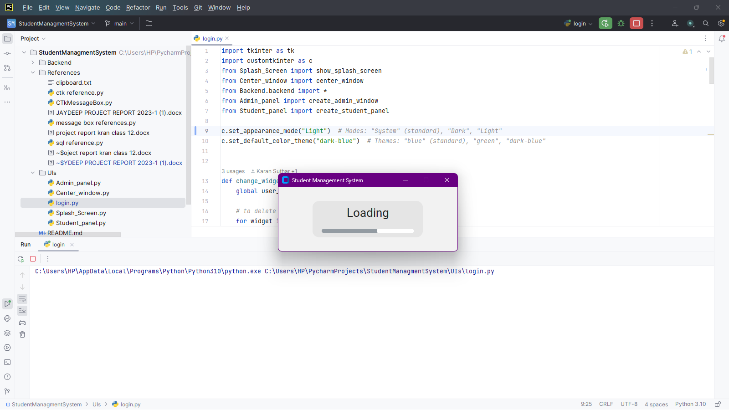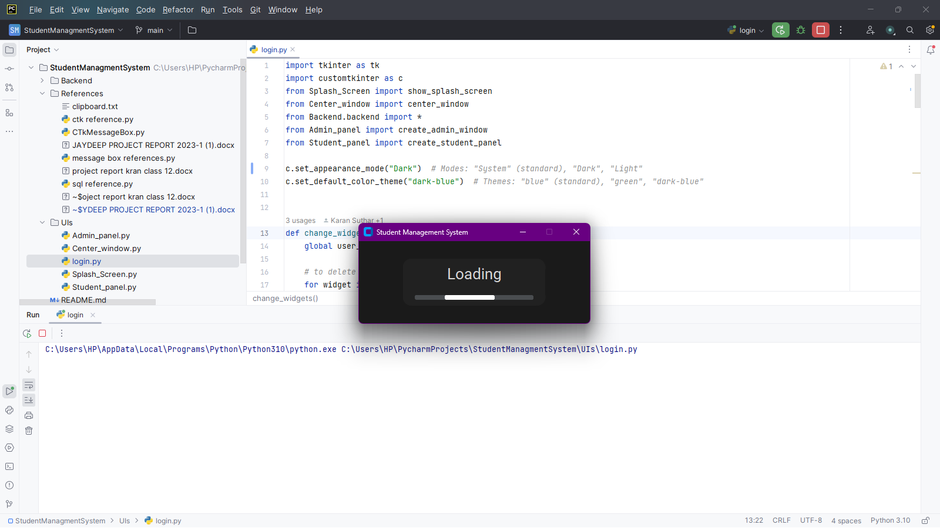

**Login.py**

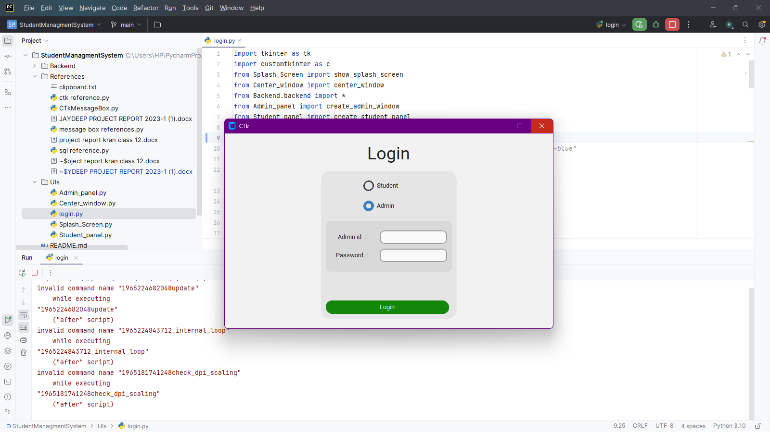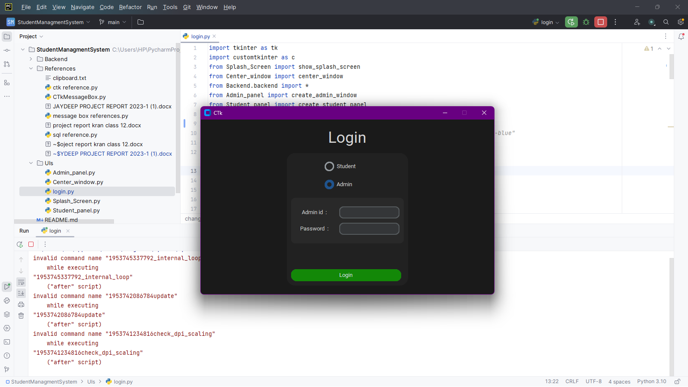

**Admin_panel.py**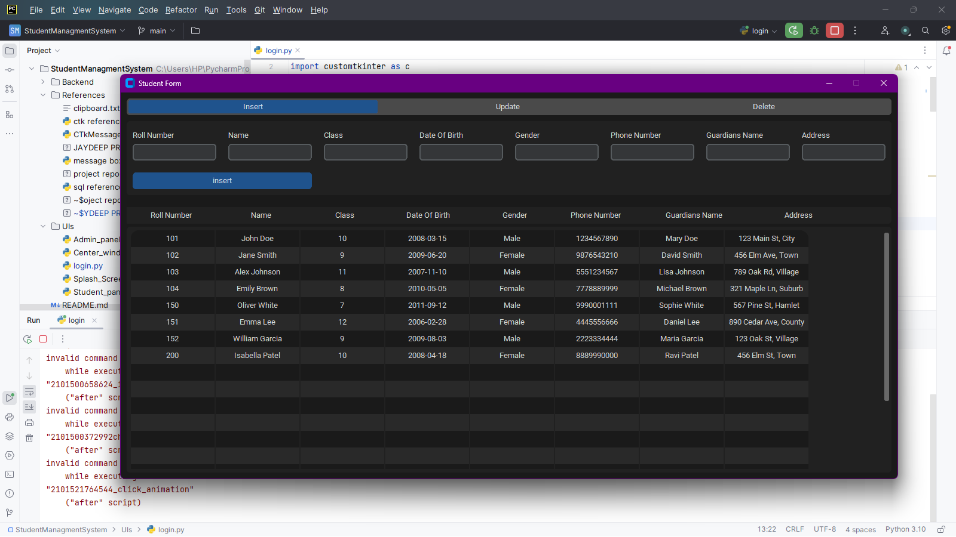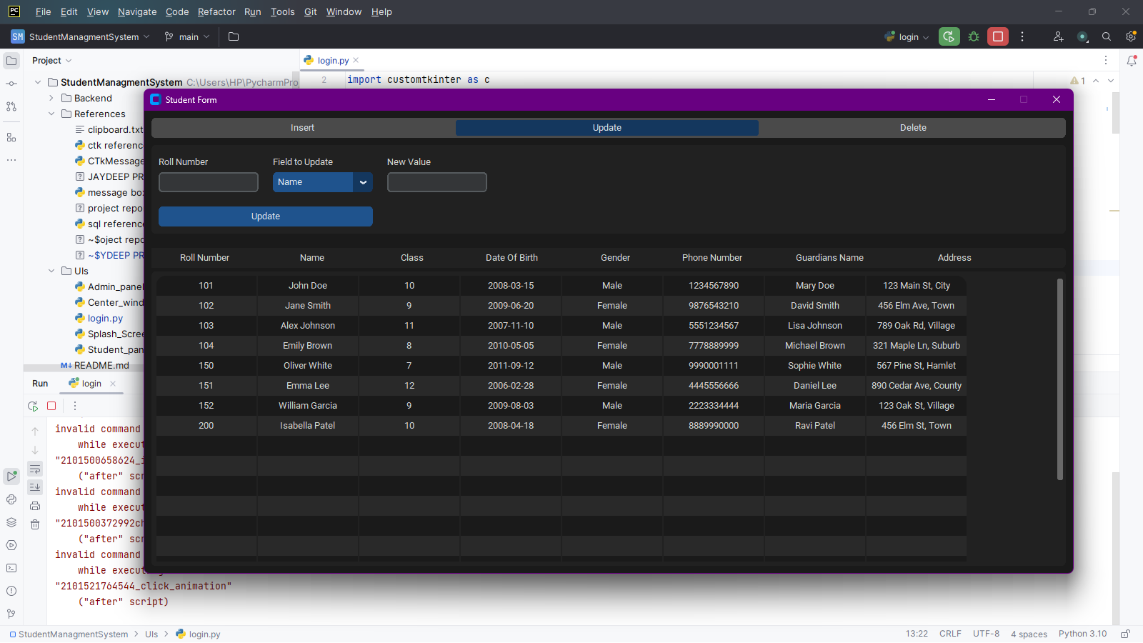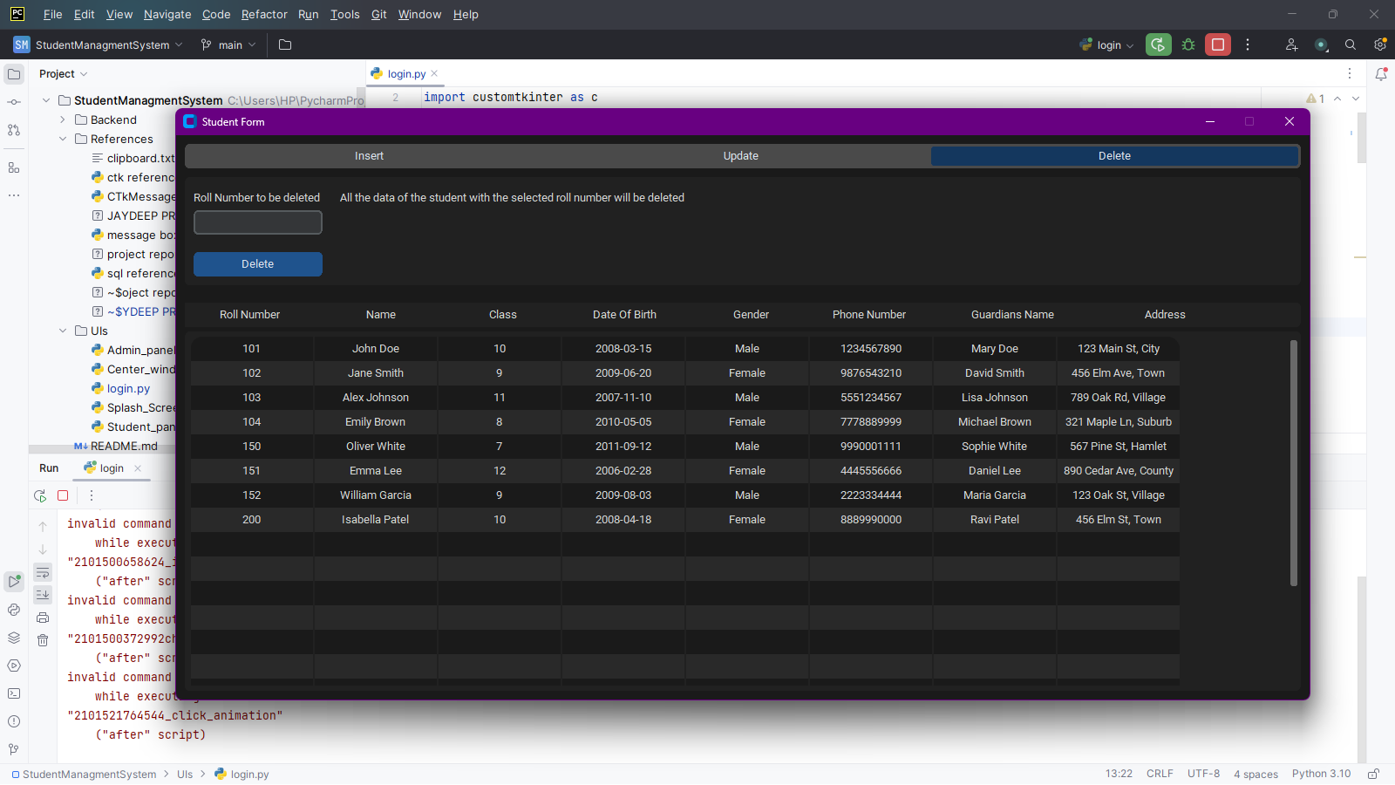

**Student_panel.py**

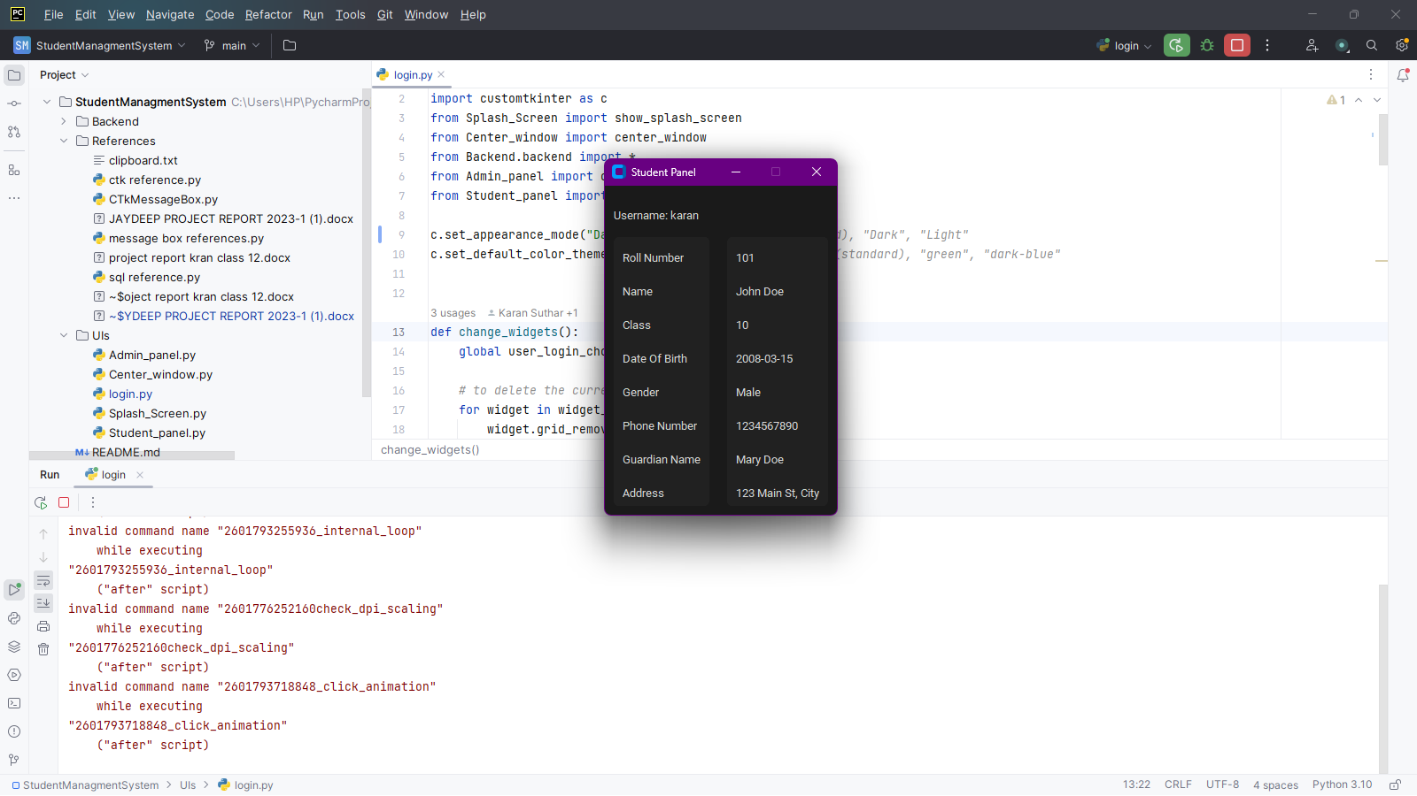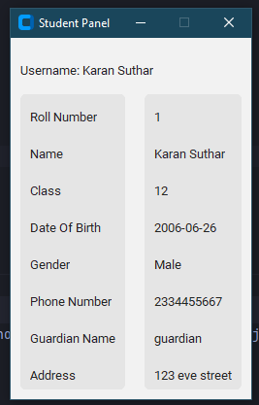

**TABLE STRUCTURE**

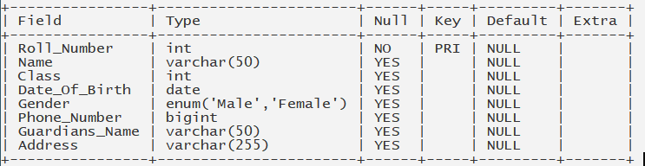

This table structure represents a database table with the following fields:

1. **Roll_Number**: This is an integer field and is the primary key of the table. It cannot be NULL.
2. **Name**: This is a variable character field with a maximum length of 50 characters. It can be NULL.
3. **Class**: This is an integer field. It can be NULL.
4. **Date_Of_Birth**: This is a date field. It can be NULL.
5. **Gender**: This is an enumerated field which can take the values ‘Male’ or ‘Female’. It can be NULL.
6. **Phone_Number**: This is a big integer field. It can be NULL.
7. **Guardians_Name**: This is a variable character field with a maximum length of 50 characters. It can be NULL.
8. **Address**: This is a variable character field with a maximum length of 255 characters. It can be NULL.

**BIBLIOGRAPHY**

1. [www.greeksforgreeks.org](http://www.greeksforgreeks.org/)
2. [github.com/TomSchimansky/ CustomTkinter](https://github.com/TomSchimansky/CustomTkinter)
3. www.w3schools.com/MySQL/default.asp

2.) Help from textbook i.e. computer science class XII by Preeti Arora.

3.) Help from Subject Teacher.